
Content
Intruduction 2
What is a 2D engine? 2
Engine specs 2
Good to know 3
License 3
Tutorials 4
Tutorial 1: Setting it up in visual studio 4
Code tutorials 4
Tutorial 2: Rendering a sprite 5
Tutorial 2b: Manipulating sprites 6
Tutorial 3: Spritebatch 8
New fonts? 9
Tutorial 5: Lights 10
Tutorial 6: Video 11
Tutorial 7: Render target 12
Tutorial 10: Custom shape 13
Tutorial 11: Spine Animations 14

Introduction
Hello and welcome to the wonderful world of 2D graphics! This engine is created for the purpose of having easy access to advanced rendering techniques. The engine is created in house meaning that most of the teachers here at TGA will have knowledge of it and can always be of assistance. The engine will be updated the more we use it and with newer tech coming.

What is a 2D engine?
A 2D engine is a framework where the developer can use interfaces and simple techniques without the knowledge of how the underlying tech works. To load a image and draw it on the screen is a complicated process and will take many hours to get right. A engine will have this functionality already written, and exposes simple functions.
There are a lot of 2D engines created: https://en.wikipedia.org/wiki/List_of_game_engines
So why not use one of them?
The simple answer is that with our own engine, we have full control and can develop it further to suit this education. If problems would appear, we can handle it here instead of writing to the creater of the 3rd part engine.

Engine specs
DirectX 11
Supports out of the box:
-Text
-Sprites
-Sprite batches
-Video
-Audio
-Skinned 2D Animation
-Lights
-Line drawing
-Custom drawing

Good to know
This engine operates in a normalized space, meaning nothing is in pixel space.
Left top of the screen is position X:0 Y:0. Right bottom is position X:1 Y:1. You can still set positions outside of these, but then you need to move the “camera” to be able to see it.
Colors are also in the normalized space 0.0 -> 1.0
You have the full source! Don’t be afraid to get your hands dirty!
Keep it within The game assembly please. We want to support you here 100% at school with it. That does not mean you can take it home and on other computers. If you have improvements, please tell us!
Compatible operating systems: Windows 7, Windows 8.X, Windows 10

License
As this engine is developed here at The Game Assembly, you can not create and sell a product with TGA2D. (aka. Free for non commercial use).
If you are looking for an engine to release your own games with we recommend looking at SDL

Tutorials

Tutorial 1: Setting it up in visual studio
The engine consists of one solution containing three projects: “DX2Dengine” , “Game” and “Launcher”.
DX2Dengine: This is the main project where everything engine related is.
Game: This is where your game code will be.
Launcher: This is a small project starting up your game code, which will then start the engine code
Start up the solution:
The project is always started via: TGA2D\Application\Application.sln (sln is important or your will see an empty project)
If you start it up it will load up all the projects. Try rebuilding the solution in DEBUG. It should compile (if not, see troubleshooting in the end of this document). The engine is setup so it will create the exe files in: TGA2D\Workbed. This is the place where all the data should be placed later. If you build it in debug, the generated exe will be named: Launcher_Debug.exe, if in release: Launcher_Release.exe. Two exes are always good so we don’t mix them up when we send it to artists. [Never send a debug exe to them].

Code tutorials
We have some tutorials set up as well. Start them with “Application_Tutorials.sln”

Tutorial 2: Rendering a sprite [Tutorial 2 in the code solution]
We have skipped out on most of the image formats supported to give you a good ground on how to
create and load textures(actual images). The engine craves the image format .dds [https://en.wikipedia.org/wiki/DirectDraw_Surface]. This image format is good in a number of ways when dealing with game engine textures. The image can be saved with mip maps[https://en.wikipedia.org/wiki/Mipmap] (useful later in 3D), and is enforced to be in a resolution power of 2 which is optimized in shaders and will generate more frames per second.

The fun stuff:
Lets render an image!
The only thing we need to do is create an instance of the class DX2D::Csprite
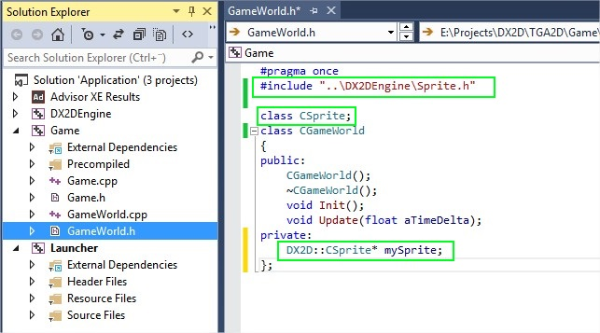
Then in gameworld.cpp
#include <tga2d/sprite/sprite.h>
void CGameWorld::Init()
{
mySprite = new Tga2D::CSprite("tga_logo.dds"); ← the path needs to be relative to youryour bin folder
mySprite->SetPosition(DX2D::Vector2f(0.5f, 0.5f));
}
void CGameWorld::Update(float aTimeDelta)
{
mySprite->Render();
}
Thats it! Compile and run and you should see something like this:
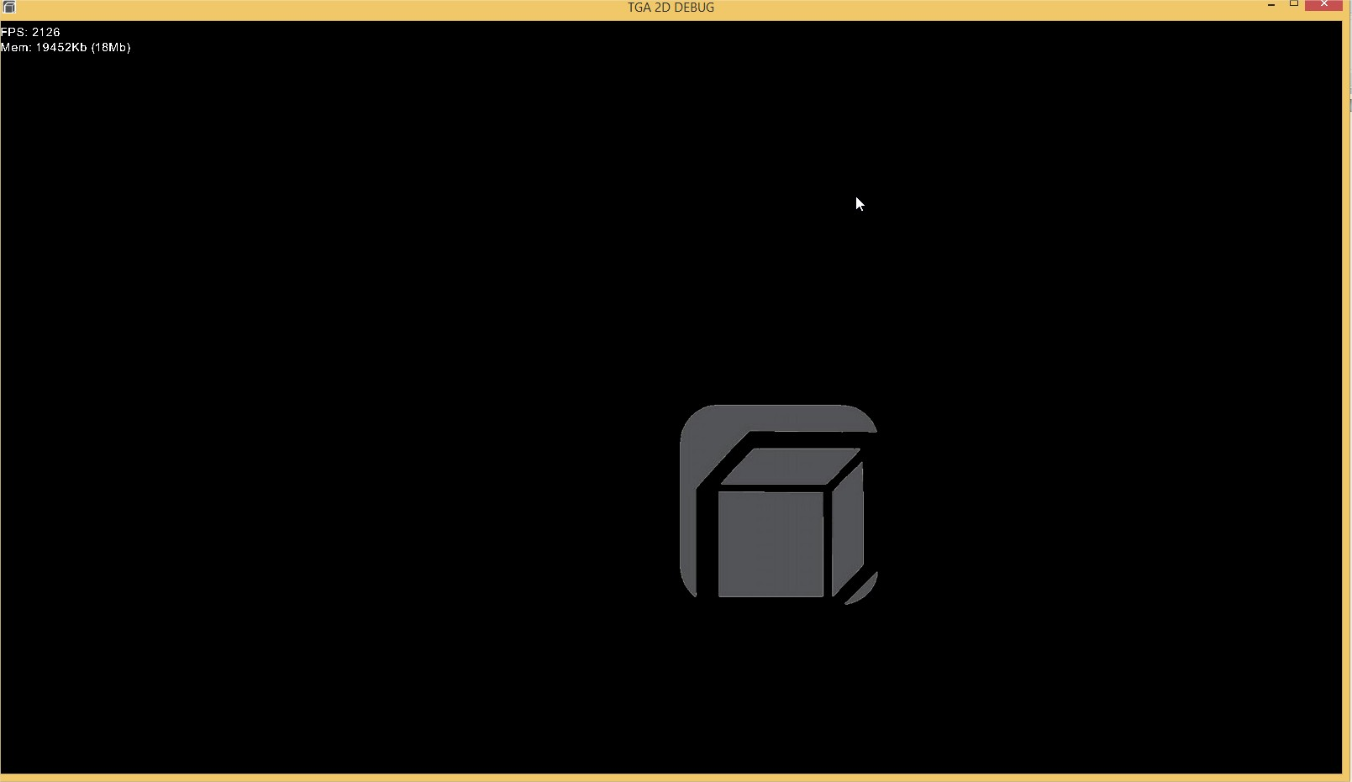

Tutorial 2b: Manipulating sprites
If you peek into the Csprite class you will see a number of functions.
void SetPosition(const Vector2f& aPosition); - Sets the sprite on a position
const Vector2f& GetPosition() const; - Gets the current position of the sprite
void SetPivot(const Vector2f& aPivot); - Sets the pivot point of a sprite, this is to tell the sprite on where it shoudl have the origin position, useful when rotating the sprite
const Vector2f& GetPivot() const; - Gets the pivot point on a sprite
void SetRotation(const float aRotationInRadians); - Sets the rotation in radians
float GetRotation() const; - Gets the rotation in radians
void SetColor(const CColor& aColor); - Sets the color (multiplied by the texture color) , Ccolor takes four values, Red, Green, Blue and Alpha. Alpha is the transparacy valuie.
CColor GetColor() const; - Gets the color
void SetSizeRelativeToScreen(const Vector2f& aSize);
void SetSizeRelativeToImage(const Vector2f& aSize);
virtual Vector2f GetSize() const; - Gets the size
virtual Vector2<unsigned int> GetImageSize() const; - Gets the image size in pixels
void SetUVScale(Vector2f aScale); - Sets the UV scale, useful of you want the texture to loop
Vector2f GetUVScale() const; - gets the UV scale
void SetTextureRect(float aStartX, float aStartY, float aEndX, float aEndY); - Sets a region of the texture you want to render, useful in spritesheets and animations
STextureRext* GetTextureRect(); - Gets the texture rect
void SetUVOffset(Vector2f aUV); - Sets an offset to the UV, useful when scrolling a texture
virtual Vector2f GetUVOffset() const; - Gets the UV offset
bool HasChangedSize() const {return myHasChangedSize;} – used in rendering
void SetShouldRender(bool aShouldRender){ myShouldRender = aShouldRender; } – set to false if you want to hide it, mostly used in batches when you don’t have control of a single sprite rendering.
bool GetShouldRender() const { return myShouldRender; } – Gets if this should render
void SetMap(const EShaderMap aMapType, const char* aPath); - Set an effect map, normal map for instance.
void ReleaseAttachedTexture(); - Release the resource bound to the sprite. Warning! Be aware that if anything else is using that resource, it will be invalid efter this
CColor GetPixelColor(unsigned short aX, unsigned short aY); - Will return you the pixel at that position of the sprite(texture), this is only avalible with textures formatted with A8R8G8B8

An easy way to take this for a test drive is to create a member in GameWorld.cpp called:
float mySpriteRotation;
And in your update();
void CGameWorld::Update(float aTimeDelta)
{
mySpriteRotation += aTimeDelta;
mySprite->SetRotation(mySpriteRotation);

mySprite->Render();
}

Don’t forget to initialize your mySpriteRotation in the constructor to 0.0f.
Compile and go!
If you want it to rotate around it center, set the pivot to X:0.5f, Y:0,5f.
(mySprite->SetPivot(Tga2D::Vector2f(0.5f, 0.5f));)
Neat!

Tutorial 3: Spritebatch [Tutorial 3 in the code solution]
Spritebatch is something you want to use if you have a sprite with the same texture that is used multiple times on the screen. This can include a spritesheet, particles etc.
By using a spritebatch you will improve the performance a lot. A sprite batch consist of multiple CSprite objects without its texture as that is present in the batch. See sample code:
.h file:
DX2D::CSpriteBatch* mySpriteBatch;
.cpp file
void CGameWorld::Init()
{
mySpriteBatch = new Tga2D::CSpriteBatch(true);
mySpriteBatch->Init("tga_logo.dds");
for (short i = 0; i < 10; i++)
{
Tga2D::CSprite* sprite = new Tga2D::CSprite(nullptr);
sprite->SetPosition(Tga2D::Vector2f(static_cast<float>(i) / 10.0f, 0.5f));
mySpriteBatch->AddObject(sprite);
}
}
Update
void CGameWorld::Update(float aTimeDelta)
{
mySpriteBatch->Render();
}

This will render 10 sprites. Note that if you want to hide one, this is where the function on the sprite: SetShouldRender() comes in handy.
Use the spritebatch as much as possible, as one batch equals one draw call[calls to the graphic card]. The less draw calls the more performance.
Q: Why not use them all the time then?
A: Because of Z sorting. We can not sort Z (depth) between different sprites in different batches as we draw one batch on the screen, it is drawn. We can not draw underneath it anymore, only over it. We can however sort Z within one batch (by adding them in a different order when we create it). If you need to sort them individually, batch is not the answer.
Tutorial 4: Text [Tutorial 4 in code solution]
To add a text to the screen simply include:
#include <tga2d/text/text.h>
Add a pointer to a text object as a member:
Tga2D::CText* myText;
In the init:
void CGameWorld::Init()
{
myText = new Tga2D::CText("Text/arial.ttf"); // The ttf must exist in the data folder
myText->myText = "Hello future";
myText->myPosition = Tga2D::Vector2f(0.5f, 0.5f);
}
Update:
void CGameWorld::Update(float aTimeDelta)
{
myText->Render();
}

The constructor takes the font. This is located under: TGA2D\Workbed\Text. It also takes the size. E.g. EFontSize_14. You can scale it as well. But use the size as much as possible as it will give you the best quality

New fonts?
TGA2D uses true fonts which mean you can grab fonts where you want. Search google for “free fonts” and use them ☺ (read the license of the font you download)

Tutorial 5: Lights [Tutorial 5 in the code solution]
Light make a great addition to any game, and we support it directly for you to experiment with.
With no light ever created, everything will be unlit with the same “light” as the texture itself have (ambient). As soon as we add a light, everything will be dark if not lit by the new light.
Adding a light:
.h file
#include <tga2d/light/light.h>
Tga2D::CLight* myLight;
.cpp file
void CGameWorld::Init()
{
myLight = new Tga2D::CLight();
myLight->myColor.Set(0.5f, 0.5f, 0.5f, 1);
myLight->myPosition.Set(0, 0);
myLight->myFallOff = 0.5f;
myLight->myIntensity = 2.0f;
}
Update
void CGameWorld::Update(float aTimeDelta)
{
myLight->Render();
}
This will add a light. Add a sprite and have the light be over it and it will lit up. If you want to make the whole world to be darker, use this:
Tga2D::CEngine::GetInstance()->GetLightManager().SetAmbience(0.0f);
Experiment with this value a bit to suit your game. It goes negative as well.

Note: 8 light are supported at one time. If you want more light, you need to write logic to turn off and on lights (not calling render on them) depending on where you are in the world. No need to have lights at X:0, Y:0 if your camera is looking at X:2000 Y:2000.

Tutorial 6: Video
Videos make a great addition to a game. We support a lot of formats (depends on what codec you have installed. Keep it to MP4 to support most machines) :
At the moment we do not support audio as you need to include your own audio api.
Fun stuff:
Playing a video
.h file
#include <tga2d/video/video.h>
Tga2D::CVideo* myVideo;
.cpp file
Init
void CGameWorld::Init()
{
myVideo = new Tga2D::CVideo();
myVideo->Init(L"tga.mp4");
myVideo->Play();
}
Update
void CGameWorld::Update(float aTimeDelta)
{
myVideo->Update(aTimeDelta);
myVideo->Render();
}

The video itself contains a lot of logic to extract the video via a stream. But in the end it will result in a sprite. This sprite can be manipulated in all the ways a ordinary sprite will, including lights.

Tutorial 7: Render target [Tutorial 7 in the code solution]
A render target is something we render stuff on
It could be the screen, or something else. In TGA2D you can choose to render on a sprite.

This can be useful when you want to apply a full screen shader effect that is not “per sprite” but more “per screen”.
You can get inspiration on www.shadertoys.com and search “full screen” to see what effects you can apply.

Tutorial 10: Custom shape [Tutorial 6 in the code solution]
Custom object is a way to draw your own object consisting of points, making up polygons.
Fun stuff:
Include: #include <tga2d/primitives/custom_shape.h>
.h file
Tga2D::CCustomShape* myCustomShape;
.cpp file
//INIT
myCustomShape = new Tga2D::CCustomShape();
CColor color = CColor(0, 0, 0, 1.0f); //Black!
// First poly
myCustomShape->AddPoint(Tga2D::Vector2f(0.0f ,0.0f), color);
myCustomShape->AddPoint(Tga2D::Vector2f(0.0f ,1.0f), color);
myCustomShape->AddPoint(Tga2D::Vector2f(1.0f ,1.0f), color);
// Second poly
myCustomShape->AddPoint(Tga2D::Vector2f(1.0f ,0.0f), color);
myCustomShape->AddPoint(Tga2D::Vector2f(0.0f ,0.0f), color);
myCustomShape->AddPoint(Tga2D::Vector2f(1.0f ,1.0f), color);
myCustomShape->BuildShape(); //This is needed to verify your shape
//Update
myCustomShape->Render();

You can also set a texture on your shapes. Use the last Vec2 in the AddPoint() function for this to set UV coordinates.
Don’t forget to set the texture as well with SetTexture() on myCustomShape

Quirks:
1. Number of points must be divided equal with 3 (BuildShape() verifies this)
Q:What should I use it for?
A: Maybe burn tracks? ☺
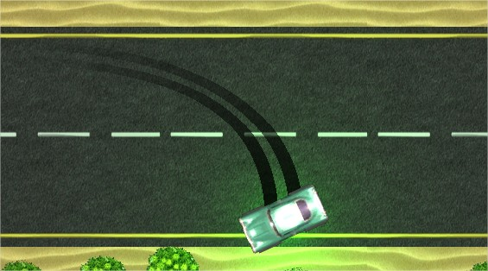
(Made with this engine and with custom shape)

Tutorial 11: Custom shape [Tutorial 11 in the code solution]
TGA2d supports exported animations from Spine. Pro-tip: talking with your animator may clear up questions.
Fun stuff:
Include: #include <tga2d/animation/spineAnimation.h>
Forward declaration:
Tga2D::CSpineAnimation* myAnimation;
.cpp file
//INIT
myAnimation = new Tga2D:: CSpineAnimation();
// files exported by animator
myAnimation->Init("animTest/textures.atlas", "animTest/animation.json");
// animation name is set by animator
myAnimation->AddAnimationToQueue(0, "animationName", true, 0);
myAnimation->SetPosition({0.5f, 0.5f});
//Update
myAnimation->Update(aDeltaTime);
myAnimation->Render();

Animation event callbacks:
There’s two types of event callbacks:
- Built-in with spine: start, interrupt, end, complete, dispose
- Custom event: made by your animator
Build-in events are registered with RegisterAnimationCallback and custom made with RegisterAnimationEventCallback.
The second argument is “aRegisterID”. If a observer dies it needs to tell the animation to unregister. It’s not possible to unregister with a std::function.
In case the animation only has one observer, just put 0 as registerID and don’t think much about it unless the observer dies before the animation object.
The registerID is handled by you and not created from spine or any other system.
Type of event from build-in callback can be found in the argument list.
Custom values entered by your animator is also found in the argument list for the custom made events.

Debug tools

To be able to debug things easier ingame, you can draw lines, text and print log messages(se Useful information).
To draw a line, simple do this:
Tga2D::CEngine::GetInstance()->GetDebugDrawer().DrawLine(DX2D::Vector2f(0.3f, 0.7f), Tga2D::Vector2f(0.3f, 0.8f));

Draw an arrow:
Tga2D::CEngine::GetInstance()->GetDebugDrawer().DrawArrow(DX2D::Vector2f(0.3f, 0.7f), Tga2D::Vector2f(0.3f, 0.8f));
There is a bool controlling the FPS text/memory text, simply set this to false to remove those in Game.cpp
Tga2D::SEngineCreateParameters createParameters;
createParameters.myActivateDebugSystems = A lot of features;

eDebugFeature_Fps = 1 << 0,
eDebugFeature_Mem = 1 << 1,
eDebugFeature_Drawcalls = 1 << 2,
eDebugFeature_Cpu = 1 << 3,
eDebugFeature_FpsGraph = 1 << 4,
eDebugFeature_Filewatcher = 1 << 5,
eDebugFeature_OptimiceWarnings = 1 << 6,
eDebugFeature_All = 1 << 7,
set to 0 if you don’t need it.
If your game needs lines and arrows, keep it enabled, you can draw a few lines before it becomes performance heavy. If many uses this, we will add a new class that can handle this better.
Useful information
Logging
The engine is started by default with the command window (cmd), this is where all the logging takes place. If you want to print something, simply use the macro: INFO_PRINT()
Example:
INFO_PRINT("%s%i", "Something went right: ", myCharPointer, myInt);
ERROR_PRINT("%s", " Something went wrong! ");
This will output everything to the command window.
To disable the command window starting, remove the #define USE_CONSOLE_COMMAND in main.cpp in the “Launcher” project.

Resolution
To set the initial resolution, look in: Game.cpp:
unsigned short windowWidth = 1600;
unsigned short windowHeight = 900;
createParameters.myWindowHeight = windowHeight;
createParameters.myWindowWidth = windowWidth;
To set the resolution ingame, you can use: Tga2D::CEngine::GetInstance()->SetResolution()
To set the name of the application:
createParameters.myApplicationName = L“Such app name, much TGA”;
Memory
Keep an eye out on the memory text, if it constantly grows, you probably have a memory leak. Avoid this at any cost!
Troubleshooting

Q: It doesn’t compile
A: make sure you have everything needed for directx (DirectX SDK)
Q: Only programmers can start the exe
A: Did you send the release version?
Q: Can I change things in the engine project?
A: YES
Q: I want to add something to the engine
A: Do it
Q: I love and want to know more about shaders
A: Talk to us, we love to explain and show you how to do it!
Q: Everything looks like crap when I resize the window using the window borders
A: Yes, it will look like crap if your game doesn’t handle the resizing that way. Dont allow the player to resize the window using borders
Q: I have this problem:
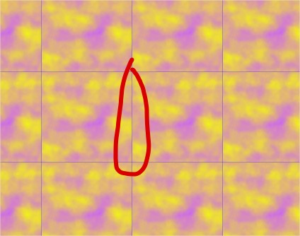
Lines are flickering even if I use the correct sizing and positioning.
A1: The problem is that we are using bilinear sampling where we interpolate to the nearest pixels.
If you have a texture: 128px * 128px and you set the texture rect to 0, 0, 0.5f, 0.5f. Where can we sample from?
We need to calculate a texel size: 1.0f / 128.0f. We get 0.0078125. This is one texel size. To get rid of our line we can then do this:
float texelsize = 1.0f / 128.0f;
myTga2dLogoSprite->SetTextureRect(texelsize, texelsize, 0.5f - texelsize, 0.5f - texelsize);

Now we get the correct result:
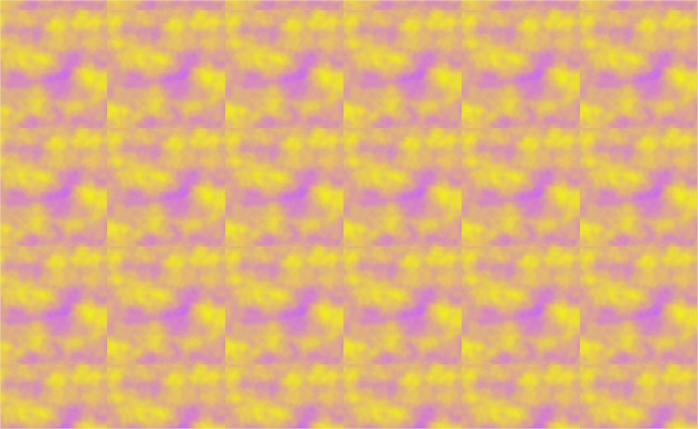

A2: Use point sampling on you sprite:
myTga2dLogoSprite->SetSamplerState(ESamplerFilter_Point);
Q: My question is not here
A: Come and talk to us

